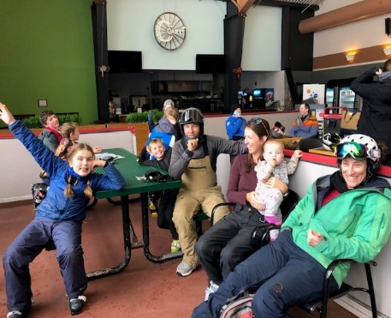
Hope School Newsletter

Check out the Hope School PTO Merch link below:
Hope Huskie’s Merch

  - January 12, 2026
This January has made for sledding opportunities for our students. They have enjoyed the use of the donated sleds from our PTO. We send out a very special thank you to all of you who have worked to bring some fun and joy into their outdoor play times. They are enjoying the unique opportunities for Alaskan students.  IMPORTANT DATES:  JANUARY 16TH, 2026: Early Release 2:00 PM/ Spirit Day (Hat Day)  JANUARY 19TH, 2026: PTO Meeting at 3:30 - We encourage you to be there for upcoming details and information.  FEBRUARY 2ND, 2026: Battle of the Books  FEBRUARY 6TH, 2026: Early Release 2:00 PM  FEBRUARY 9TH, 2026: Battle of the Books competition/PTO  FEBRUARY 12TH, 2026: No School – Parent Teacher Conferences  FEBRUARY 13^{TH,} 2026: No School – Parent Teacher Conferences  Confirmed dates for Alyeska are as follows:  2/17/2026, 3/4/2026, 3/24/2026, 3/31/2026  Please consider volunteering at the school. We have many beginning readers. Please sign up on the front board, with Mrs. Eva at the front desk or with Mr. Jeremy. He would love to have some student support from the community. |  |   Please see Christy Antista-Smith to ask questions, place direct orders or pay by check or money order. An envelope will also be prepared and remain at the front office for orders as well. This is a wonderful opportunity to sell Hope Husky Merch to raise money to support students. Here is the link for orders and many convenient ways to shop for these items:  Hope Huskie’s Merch

