Hope School Newsletter
February 05,2026
Check out the Hope School PTO Merch link below:
Hope Huskie’s Merch

Hope School Happenings
Upcoming Battle of the Books
We have two students competing at the High School level in our District. Our freshman students, Elleanor Stehn and Beverly Jabaay, have been reading and studying for the upcoming reading competition for weeks. Our school is a small school, but these students have always represented Hope School well. We wish you both the best in your reading competition on February 9th. Mrs. Christen will be leading the students through this competition this year.

School Make Up Day
Oh, the weather outside has been frightful. The snow day off in January was delightful. We do have a change in calendar this year. The calendar is below for your convenience. Our official day for snow Make Up Day is set for February 16th. The calendar now reflects February 16th as a school day. Make sure to update your calendars.

Alyeska
Please see Mrs. Christen or Mr. Jeremy with any questions you may have in reference to the Alyeska ski trips. The forms are due to Mrs. Christen.

Ski Dates: February 17th, March 4th, March 24th, March 31st

Upcoming Events
February 6th: Early Release at 2:00 PM
- Spirit Day (Masters and Minions)
February 9th: PTO Meeting at 3:45 PM
- Battle of the Books
February 12th: No School for Students - Parent Teacher Conferences
February 13th: No School for Students - Parent Teacher Conferences
February 16th- Students will have school on this day. This is a make up day for a prior SNOW DAY
February 17th: Alyeska Field Trip
March 4th: Alyeska Field Trip
March 5th: Early Release at 2:00 PM
- Spirit Day – Sports outfits
March 6th: In-Service No School for Students
March 9th-13th: Spring Break- No School for Students or Staff
March 16th: PTO Meeting
March 24th: Alyeska Field Trip
March 31st: Alyeska Field Trip

DON’T FORGET THE HOPE SCHOOL PTO IS STILL FUNDRAISING FOR OUR STUDENTS’ FUTURE IN MANY WAYS. THE MERCHANDISE LINK IS LOCATED IN THE FIRST PAGE HEADING FOR YOUR ORDERING CONVENIENCE!
An updated District Calendar is below for your convenience. 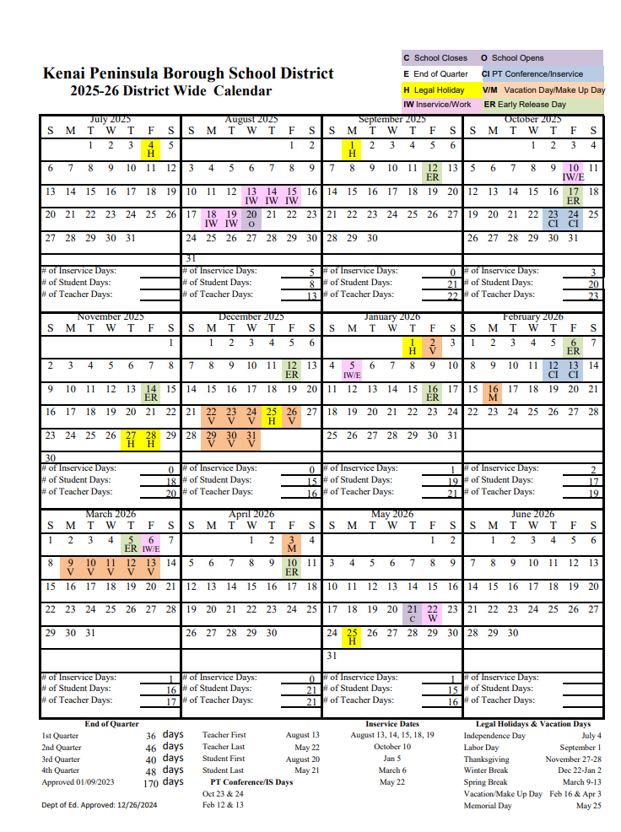
Alaska MAP testing (part of the AK STAR system for grades 3-9) can be practiced through the official state website, which provides online sample tests, tutorials, and, if needed, accommodations like text-to-speech for ELA and math. These resources familiarize students with the format, tools (calculator, highlighter), and question types to improve performance on fall, winter, and spring assessments.
Key Resources for Alaska MAP Practice:
- NWEA MAP Growth Practice: Provides direct, untimed access to practice questions to get comfortable with the testing interface.
Tips for Success:
- Use the Secure Browser: Download the NWEA secure browser for the best simulation of the testing environment.
- Understand the Test: The tests are adaptive, meaning they adjust to the student's ability level, making it important to focus on accuracy rather than speed.
- Review Skills: Focus on reading comprehension (main ideas, themes) and math (problem-solving, equations). how to navigate the test.

