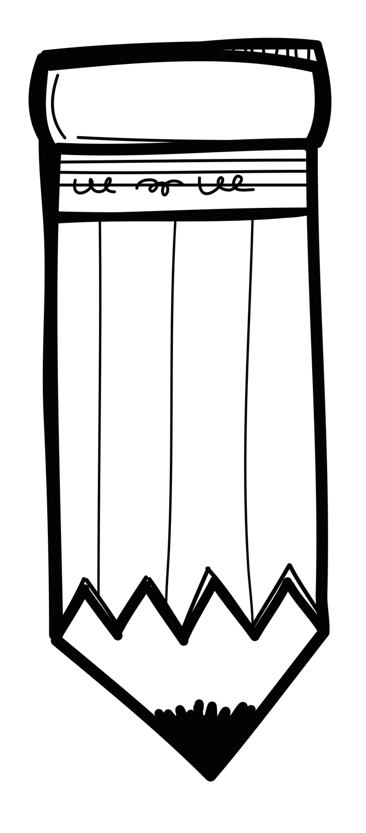Second Grade Supply List
K-Beach Elementary
2026-2027

- backpack (full-sized, sturdy, labeled inside with child’s name)
- gym shoes (first name on each shoe)
- headphones for computer use (labeled in a Ziploc bag)
- Pencil pouch or box
If possible, please consider sending the following:

- 1 box of Ziploc bags
- $20 activity fee (for classroom activities and materials, such as magazines, reading challenges, field trips, etc.)

- 2 dozen #2 pencils (Ticonderoga are recommended)
- Crayons – 24 count
- Colored pencils
- 2 dry erase markers
- 2 fine point Sharpies
- 12 glue sticks or 2 liquid glue bottles
- 1 plastic 2-pocket folder
- 1 wide-ruled spiral notebooks
- student scissors
- reusable water bottle
- 1 large box of tissues
- 1 bulk snack

