**­August 17, 2021**

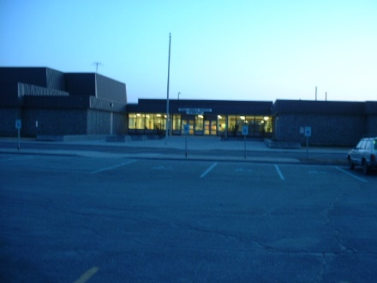**Dear 7th grade parent(s):**

**Welcome to the 2021-2022 school year at Kenai Middle School! We as the 7th grade core-subject teachers are looking forward to an exciting productive year working with you and your child.**

**We will be keeping in close touch with you all year long. Please do the same with us. We welcome your calls and comments. Any time you have anything you would like to discuss with us, please call the school office at 283-1700 and ask for your child's 7th grade team teachers. If we are unavailable, we will return your call as quickly as possible.**

**Sincerely,**

**The 7th Grade Core Team**

**Nolan Rose Mike Gustkey Amanda Adair**

**Tony Lewis Chelsea Newton Kim Navarre**

**Attached is a list of recommended materials for the 7th grade year.**

**In order to get off to a successful start, your child will need the following materials for the 7th grade academic team. These supplies should be in you possession at all times throughout the year. Please make sure that your student has all of his or her supplies throughout the course of the school year.**



**1. Pencil/Pen Pouch**

**2. 2 boxes of #2 pencils**

**3. 10 blue ink pens**

**4. 2 boxes of colored pencils**

**5. 8 pocket folders (various colors, 1 per**

**core-subject/elective class)**

**6. 8 separate 70 lined-sheet spiral-**

**notebooks (1 per core-subject/elective**

**class)**

**7. Optional – Scientific Calculator**