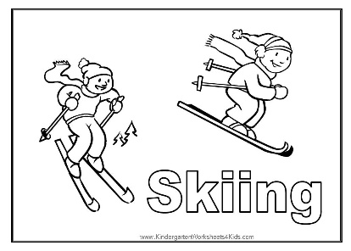
This Photo by Unknown Author is licensed under CC BY-SA
Alyeska Itinerary 2026

8:15 -Early school drop off! The bus will be picking up students 10 minutes early who live south of the school. Stopping by the school to do pick-ups.
8:25-9:45 – Travel to Alyeska-Stopping along the way for north of school pick-ups.
9:45-10:00 – Arrive: use bathroom, eat snack, get gear, get to lessons.
10:00-12:30 – Lessons
12:30-12:50 – Eat lunch
12:50–1:40 – Free ski with chaperones
1:40-1:55 – Return gear to day lodge & bathroom break
1:55-2:00 – Roll call & board bus
2:00-3:15 – Travel to Moose Pass School
3:15-Pick up and school bus drop off for south of school students will be as usual

Students should have:
Lunch/snack & water bottle
Waterproof coat and snow pants
Gloves (2 pairs) & hat
Long/thick socks
Boots (no tennis shoes)
Change of clothes (in case they get wet)
Entertainment or comfort item for the long bus ride

