Moose Pass School Site Based Council Agenda----Wednesday January 14th, 2026
- Roll call
- Approval of agenda
- Approval of Minutes
- Reports of officers, boards, committees
  - Principal’s report
  - Teacher’s report
    - Sandra
    - Laura
  - Additional reports: Financial ($6,910.28)
    - We received $2,000 from the MPSC for skiing and/or other field trips
    - Title I funding will cover ski lesson costs
- Alyeska Skiing/Lessons
  - Dates-Jan 27, Feb 10, March 3 or 4, March 24, (March 31st make up day)
  - Chaperon costs-will need to know the Friday before who is coming.
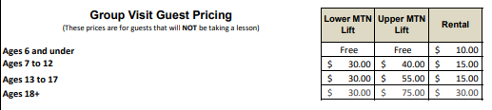
- P& F Engagement School Policy-
- Additional Items for the Good of the Order:

- Next meeting
- Adjournment

