Moose Pass School Site Based Council Agenda----Wednesday January 14th, 2026
- Roll call
- Approval of agenda
- Approval of Minutes
- Reports of officers, boards, committees
  - Principal’s report
  - Teacher’s report
    - Sandra
      - Sealife Center field trip, dates available-artist in residency
      - Moose Pass School (dropping the elementary)
    - Laura
  - Additional reports: Financial ($6,910.28)
    - We received $2,000 from the MPSC for bussing and/or other field trips
    - Title I funding will cover ski lesson costs
    - Anonymous donor donated funds to pay off Seward Area schools student lunch debts, the remaining $1,400 was donated to Moose Pass School to purchase snacks, lunch and breakfast. Any requests??
    - Food Service, offering snack foods provided by Cooper Landing Baptist Church and Moose Pass Fellowship. Requests or ideas for foods to offer?
- To move forward with getting your school on the schedule for SnowSchool, we need confirmation whether February 19th will work.
Field Trip - cost $5/student*** - minimum fee set based on 15 students participating
Duration: 3.5-hour field trip day (plus transportation time) + a pre and post trip classroom visit (1 hr each)
Field Trip Location: Devil's Creek Ski Area - with option for no cost bussing available in KMTA van for up to 13 students and 1 school staff.
Program Focus: Choice of focus on Winter Ecology "Our Forests in Winter" or Snow Science "Water, Snow and Ice"
*** Youth360, a program of Seward Prevention Coalition, is helping sponsor SnowSchool for Moose Pass School. Their support of the program brings the cost to the school down to $5/child (from $20/child without this support).
Callie also needs the following info:
# of students/grades participating:
Program Focus (Winter Ecology or Snow Science):

- Alyeska Skiing/Lessons
  - Dates-Jan 27, Feb 10, March 3 or 4, March 24, (March 31st make up day)
  - Chaperon costs-will need to know the Friday before who is coming.
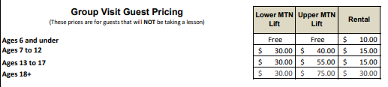
- P& F Engagement School Policy-
- Additional Items for the Good of the Order:
  - Mural-Wendy Bryden
- Next meeting
- Adjournment

