Moose Pass School Site Based Council Agenda----Wednesday March 18th, 2026
- Roll call
- Approval of agenda
- Approval of Minutes
- Reports of officers, boards, committees
  - Principal’s report
  - Teacher’s report
    - Sandra
    - Laura
  - Additional reports: Financial ($6,564.06)
- Mural Work-in need of adult community volunteers to help with this painting project!
  - 19th and 20th Tracing with Ryan Gaul 1pm-5pm
  - 26th set up
  - 27th-29th Painting all day until done.
- Alyeska Skiing/Lessons
  - March 24th
    - Dave Pearson-Charlie+3 (staying till close)
    - Chris Gordon- Louise +2 (staying till close)
    - Nathan Bawtinhimer-Bo +1?
    - Jesse Labenski-
    - Willow Labrake-Westin
    - Sandra Barron- 2
    - Laura Johnson- 4
  - Chaperon costs-will need to know the Thursday before who is coming.
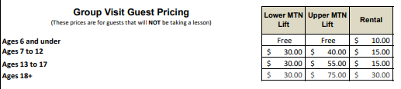

- Cirque Mechanics: TILT!
  - Saturday April 11th at 2pm
- Additional Items for the Good of the Order:
- Next meeting
- Adjournment

