Moose Pass School Site Based Council Minutes----Wednesday March 18th, 2026
- Roll call
Brooke Estes, Sandra Barron, Laura Johnson, Matt Cook
- Approval of agenda
Laura Approve, Sandra Second
- Approval of Minutes
Laura Approve, Mr. Cook Second
- Reports of officers, boards, committees
  - Principal’s report
Consolidation meeting about Seward Middle School tomorrow at 6pm at Seward Highschool Auditorium, Clayton Holand will be present. Finance meeting on Monday 3/23.
  - Teacher’s report
    - Sandra
KMTA Field Trip 3/17
Sealife center trip which included poetry with Shuana Potocky
Spring State Testing sometime in April
Mary Sandy has asked us to help recruit students to help with games booth for Summer Solstice Festival
    - Laura
  - Additional reports: Financial ($6,564.06)
- Mural Work-in need of adult community volunteers to help with this painting project!
  - 19th and 20th Tracing with Ryan Gaul 1pm-5pm
  - 26th set up
  - 27th-29th Painting all day until done.
- Alyeska Skiing/Lessons
  - March 24th
    - Dave Pearson-Charlie+3 (staying till close)
    - Chris Gordon- Louise +2 (staying till close)
    - Nathan Bawtinhimer-Bo +1?
    - Jesse Labenski-
    - Willow Labrake-Westin
    - Sandra Barron- 2
    - Laura Johnson- 4
  - Chaperon costs-will need to know the Thursday before who is coming.
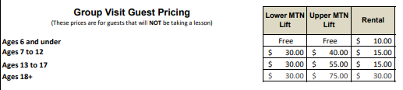
- Cirque Mechanics: TILT!
  - Saturday April 11th at 2pm
- Additional Items for the Good of the Order
  - Meal Planning for Kayakers Cove Trip-during mural painting?
    - 13th-Snack-Lunch-Dinner
    - 14th-Breakfast-Snack-Lunch
- Next meeting
  - Tuesday April 7th
- Adjournment
  - Laura Motion-Matt-Second

