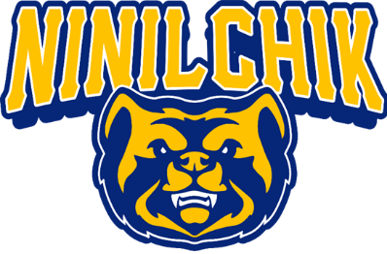
Ninilchik School News
MARCH Edition!!!!!
Third quarter is coming to a close!!!! Early Release is occurring on March 9th . There will be no school for students March 10th through the 17th for Spring Break. There has been some excitement in the school with several student’s recognized for student of the week and we are kicking off a new reading incentive program, called ‘Race to Read’. Our new reading program offers a small comprehension quiz post completion to allow our youth to set goals and see progress.

We recently hosted several teams at our Ninilchik Basketball Tournament where our very own Riley Tucker and Colvin Moore were deemed MVP’s of the tournament and the Ninilchik Boys took home 1st place. The “Baller’s Ball” was a blast of a team building evening and all youth basketball players built up some fast twitch muscles showing some different ‘moves’ on the court.
NEW STAFF MEMBER ALERT: We are ecstatic to have Ms Rebecca Paul, secondary education resource instruction, bringing an extensive educational background throughout many grade levels. Mrs Lemons has joined us as the true hub of our school, administrative assistant. Mr Stark also joined our team with a genuine outlook and a youthful approach, teaching our secondary students.

Mr. Stark's report: In 7th and 8th grade PE, the students have been strengthening their core with ab routines, planks, and push-ups with good form. They recently had a mean badminton tournament, with Onyx Allen and Lukas Vos as the winners for their grades. The students are using the hydro-gym every week to learn the proper way to lift weights with help from their high school aides, Cooper Adams and Wyatt McCloskey.
In 7th and 8th grade U.S. History the students are charging ahead with their individual research projects. They have chosen their own topics to study, which include: the birth and rise of the internet, Chernobyl, Ancient Rome, the history of Disney and more. We are studying the states and capitals, and recently learned about Mexican contributions to America.
8th grader, John Jackson, focused his project on the Japanese folklore that says folding 1,000 cranes will make a person's wish come true, and about the story of Sadako Sasaki. John and his partner, Julian Kordich, have mastered the origami crane and visited the elementary classes to teach them how to fold them. We currently have 411 folded cranes and plan to hang 1,000 cranes in the school by the end of the school year. John's project has really rippled throughout the school, where high schoolers, elementary schoolers, and middle schoolers alike can be seen folding cranes and adding them to the box in Mr. Stark's room.
In High School Physical Science the students recently learned about earthquakes, tectonic plates, and Pangaea. The Alaska Earthquake Center provided a Zoom Presentation on what the organization does, potential jobs, tsunamis, and earthquakes. And while looking at a map, they reminded us that our school is free from tsunami danger.
In High School Film as Literature we are watching a documentary called Happy People: A Year in the Taiga, that follows a group of trappers in Siberia and their villagers season by season. The students are writing blogs each week about the films we watch to demonstrate what they are learning. They are finishing the book, The Princess Bride, and will compare the book to the movie.
“It is an honor to work with the youth in our community. I learn more from them every day than they could ever learn from me.” Thanks, Mr Bob Stark
THANK YOU MR. STARK!!!! We appreciate our educators and our parents! It does take a Village…. Have a great Spring Break!

