School Supply List

Annual Student Fee (applies to both RCA & KPMCS students)
- $20 student fee ($40 per family)
For the direct benefit of & enhancement of student learning through rewards programs, breakfast programs, Interim classes, etc…

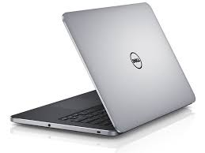
Individual Student Items (RCA only)
- Personal laptop or Chromebook:
  - RCA is not responsible for damage, theft or loss of personal items
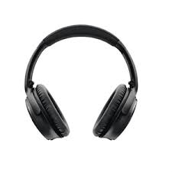
  - All electronics must be surrendered to any staff member, upon request.

- Personal headphones or earbuds

- Personal pens, pencils, etc…

- Organizer: Students need a way to organize four content classes (ELA, Math, Science and Social Studies). Work with your student to decide which works best for them.

Donation Items for School-Wide Use (RCA students only)
*We request all or some of these items as a donation to the school for student use.
- 1 package of pencils
- 1 package of Post-It/sticky notes (ANY brand, kind, color, shape, etc…)
- 2 boxes of Kleenex or facial tissues
- A package of each paper plates & paper bowls
- Middle School – Plastic or paper cups
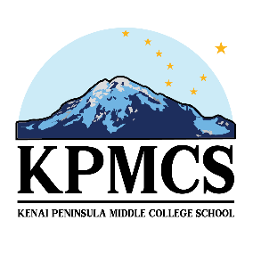
- High School – Plastic forks OR spoons

We have tried to simplify our school supplies list to items that would greatly help your student and our school out.

