Post-Secondary Planning and Information Guide

Missy Dunning, School Counselor

(907) 714-6412, [mdunning@kpbsd.k12.ak.us](mailto:mdunning@kpbsd.k12.ak.us)

River City Academy

46188 Sterling Highway

Soldotna, AK 99669



Table of Contents

Page 3-4: Important Things to Know

Page 5-6: Suggested Timeline by Grade Level 9th -12th

Page 6-7: College/Training Center Search Tools/Websites Career Exploration and Training Opportunities/Websites/**Naviance**

* Naviance is the KPBSD new College and Career readiness platform. The curriculum allows students to explore careers and interests, set goals and complete lessons on topics like Personal Finance, Financial aid, Employability skills, and create their 6 year school course plan. Naviance is being rolled out during the 2023-24 school year and is available to 6th-12th grade students.
* [Learn more about Naviance](https://ps.powerschool-docs.com/naviance/latest/naviance-overview) [Naviance Student Login](https://go.kpbsd.org/naviance-student)

Page 8: ACT Information – Dates, Locations, and Registration Information

Page 9: SAT Information – Dates, Locations, and Registration Information

Page 10-11: College Planning for 9th -10th grade

Pages 12-13: College Planning 11th grade

Pages 14-15: College Planning 12th grade

Page 16: College: “How To Get There From Here” Information

Page 17: College Application Timeline

Pages 18 : FAFSA (Free Application for Federal Student Aid) Detailed Step-By-Step Application Guide/Video link

1. Alaska Performance Scholarship-Check PowerSchool to see if you qualify

[Alaska Performance Scholarship by ACPE](https://acpe.alaska.gov/FINANCIAL-AID/AK-Performance-Scholarship)

2. Free Application for Federal Student Aid (FAFSA). Must complete the FAFSA using parent’s 2022 Tax info. NEVER use a site that charges you a fee. This is a FREE application for Federal aid based on income. Most colleges will require you to complete the FAFSA even if you will not qualify for aid. <https://studentaid.gov/h/apply-for-aid/fafsa>

## **September 24-Financial Aid Night-5:30-6:30 in Sohi Library**

3. The ACPE Success Center offers education, career training, and financial aid guidance through Zoom, email, phone, and in-person appointments. To schedule an appointment visit youcanbook.me or email [ACPESucessCenter@alaska.gov](mailto:ACPESucessCenter@alaska.gov) or call 907-269-7980.

Helpful tools to guide you through the FAFSA process https://acpe.alaska.gov/FINANCIAL-AID/The-FAFSA weekly FAFSA

<https://acpe.alaska.gov/Portals/0/OTHER/Pubs/FAFSA_At-A-Glance.pdf>

**Remember**, you should file the FAFSA as early as possible after it is released – some institutions have very early FAFSA deadlines – check with your school's Financial Aid Office to find out. Some programs may have later deadlines. The priority deadline to file the FAFSA for the [Alaska Performance Scholarship (APS)](https://acpe.alaska.gov/FINANCIAL-AID/AK-Performance-Scholarship) and the [Alaska Education Grant (AEG)](https://acpe.alaska.gov/FINANCIAL-AID/AK-Education-Grant) is June 30.

4. Parent Information Post-Secondary Planning Night at Soldotna High School in the library. September 17th 5:30-6:30 Call 907-260-7000 for more information.

5. The Common Application – Complete the Common App once, apply to many schools at once. Over 900 colleges use the Common App. Must respond in 250-650 words to one of the essay prompts. For more information, visit: <https://www.commonapp.org/> <https://www.commonapp.org/static/33342f49064800bb364191bae36b5d97/FY-Apply-College-What-is-Common-App.pdf>

## Common App has announced the 2024-2025 essay prompts. Below is the complete list of the Common App essay prompts.

1. Some students have a background, identity, interest, or talent that is so meaningful they believe their application would be incomplete without it. If this sounds like you, then please share your story.
2. The lessons we take from obstacles we encounter can be fundamental to later success. Recount a time when you faced a challenge, setback, or failure. How did it affect you, and what did you learn from the experience?
3. Reflect on a time when you questioned or challenged a belief or idea. What prompted your thinking? What was the outcome?
4. Reflect on something that someone has done for you that has made you happy or thankful in a surprising way. How has this gratitude affected or motivated you?
5. Discuss an accomplishment, event, or realization that sparked a period of personal growth and a new understanding of yourself or others.
6. Describe a topic, idea, or concept you find so engaging that it makes you lose all track of time. Why does it captivate you? What or who do you turn to when you want to learn more?
7. Share an essay on any topic of your choice. It can be one you've already written, one that responds to a different prompt, or one of your own design.

Suggested Timeline by Grade Level

9th -12th **Keep track** of **ALL** your volunteer hours, activities, involvements, and sports. Include Youth Groups, Student Council, Sports, Drama, Clubs, Dance, 4H, Rodeo, Martial Arts, Jobs, and all activities that show you are a well-rounded person. Many college applications and scholarship applications will want you to report this information.

9 th, 10th or 11th FALL: If you are in Geometry or higher, **take the PSAT** – At Soldotna High School on October 16th or 17, 2023 To sign up, pay Amanda Barber $18.00.

9 th, 10th, or 11th FALL OR SPRING: **Take the SAT and/or the ACT.** Offered at Kenai Peninsula College on Saturdays. Can be taken multiple times to improve scores. To sign up visit: [www.act.org](http://www.act.org) and/or [www.sat.org](http://www.sat.org)

10th SPRING: Explore the option of attending Middle College. Visit: [Kenai Peninsula Middle College School](https://kpbsd.org/departments/assistant-superintendent/instructional-services/secondary-education/college-career/middle-college/)

10th and 11th FALL and SPRING: Start searching for training programs, employment opportunities, and colleges.

11th and 12th FALL: Attend KPBSD’s annual College and Career Fair. October 8, 2024 11:30am-12:30 pm at Soldotna High School.

12th FALL: Apply to training programs, apprenticeships, colleges, or employment opportunities. Attend parent information nights and FAFSA workshops. Complete the FAFSA in December of your senior year.

12th SPRING: Search for scholarships and **APPLY, APPLY, APPLY**!!! Finalize details at your training program or college including Housing application, final high school transcript, and the financial aid process.

Visit KPBSD’s ONE STOP portal and use the scholarship application template to create your scholarship portfolio.

[KPBSD Scholarship Folder](https://kpbsd.org/wp-content/uploads/parents-students/onestop/KPBSD_Scholarship_Folder.doc)-<https://kpbsd.org/wp-content/uploads/parents-students/onestop/KPBSD_Scholarship_Folder.doc>

Search KPBSD’s Scholarship Database <https://kpbsd.org/OneStop/Scholarships.aspx>

Search on Student Scholarships <https://studentscholarships.org/>

Search on Fastweb <https://www.fastweb.com/>

**College/Training Center Search Tools:**

Collegeboard <https://bigfuture.collegeboard.org/>

The Alaska Career Information System (career interest profiler, college search, financial aid search, and more) <https://acpe.alaska.gov/>

Career Exploration and Training Opportunities:

* Naviance is the KPBSD new College and Career readiness platform. The curriculum allows students to explore careers and interests, set goals and complete lessons on topics like Personal Finance, Financial aid, Employability skills, and create their 6 year school course plan. Naviance is being rolled out during the 2023-24 school year and is available to 6th-12th grade students.
* [Learn more about Naviance](https://ps.powerschool-docs.com/naviance/latest/naviance-overview)
* [Naviance Student Login](https://go.kpbsd.org/naviance-student)

ACPE Success Center - training/financial aid guidance [ACPESucessCenter@alaska.gov](mailto:ACPESucessCenter@alaska.gov) Alaska Career College-[www.alaskacareercollege.edu/](http://www.alaskacareercollege.edu/) Alaska Driving Academy -CDL, Heavy Equipment, [www.alaskadrivingacademy.com](http://www.alaskadrivingacademy.com) Alaska Job Center Network <https://labor.alaska.gov/splash/alexsys/> Alaska Vocational Technical Center-avtec.edu/ Amundsen Educational Center – Construction Training, Housing, [www.aecak.org](http://www.aecak.org) Apprenticeship search <https://awib.alaska.gov/apprentice/index.html> Construction Trades-<https://helmetstohardhats.org/explore-trades/> Explore the Trades: Plumbing/HVAC/Electrical-explorethetrades.org/

Mapping your Future: <https://www.mappingyourfuture.org/index.cfm> Northern Industrial Training- CDL, heavy equipment [www.nitalaska.com/](http://www.nitalaska.com/) Nursing [Careers-www.registerednursing.org/nursing-careers/](http://careers-www.registerednursing.org/nursing-careers/) O*Net – Job search, resume builder tools <https://www.onetonline.org/> RoadTrip Nation Career Exploration- [roadtripnation.com/explore/interests](http://roadtripnation.com/explore/interests)

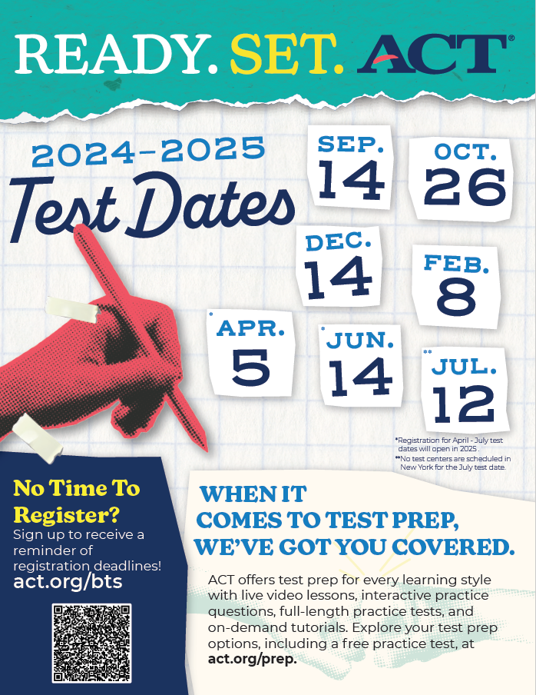

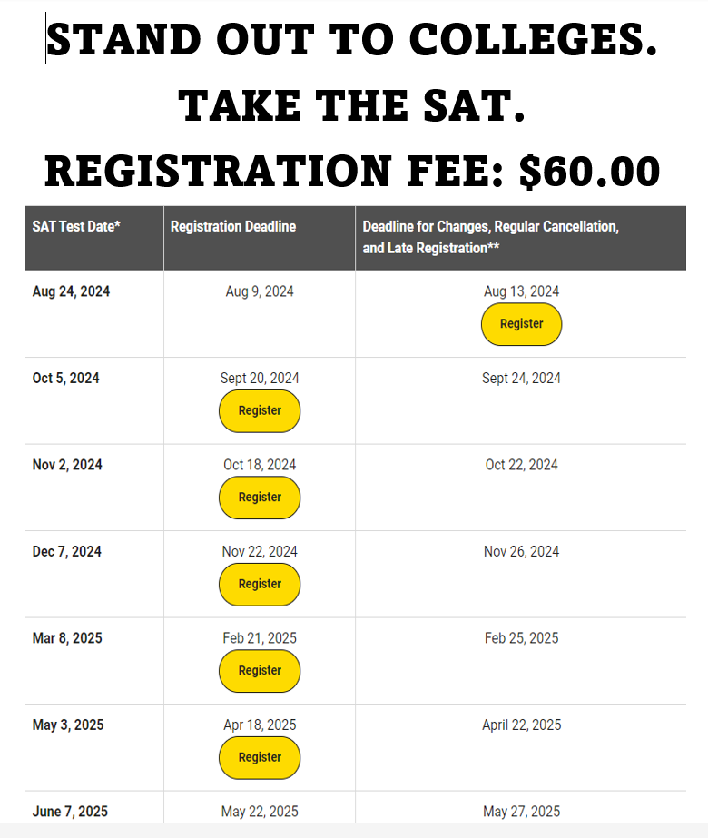

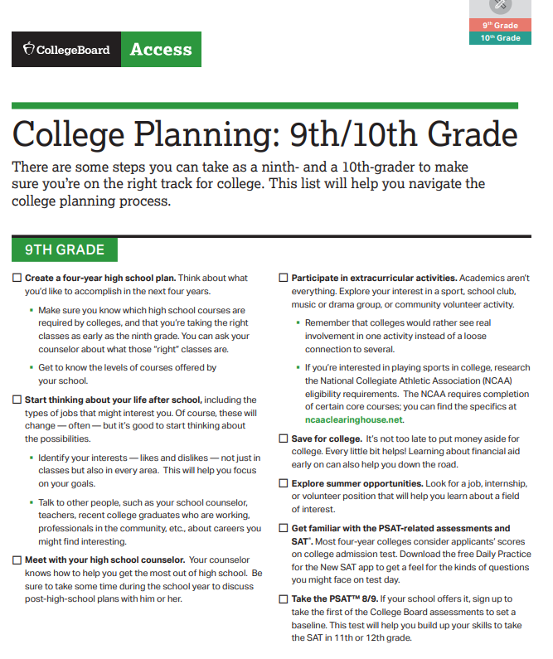

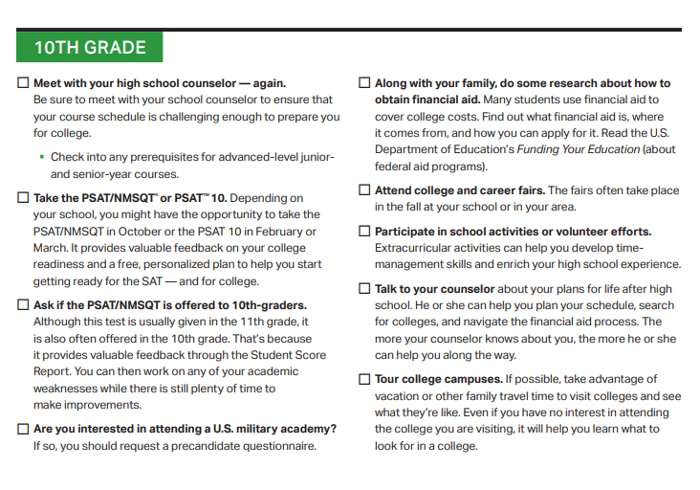

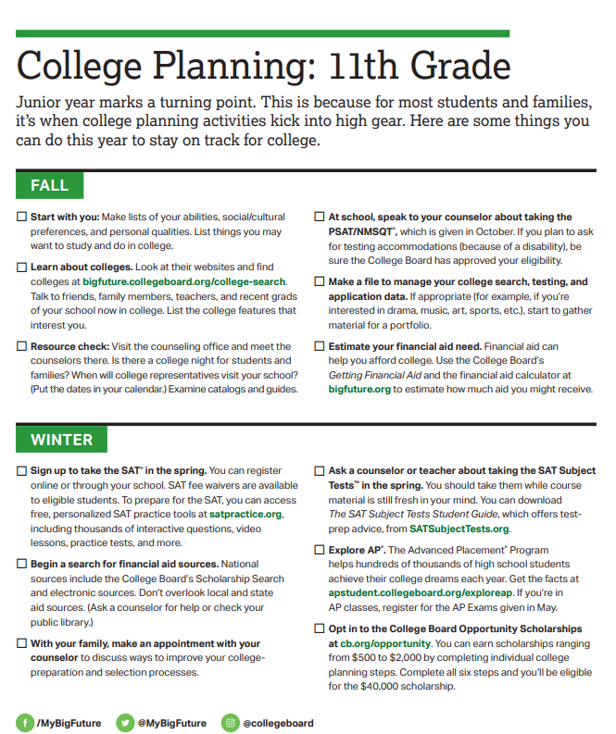

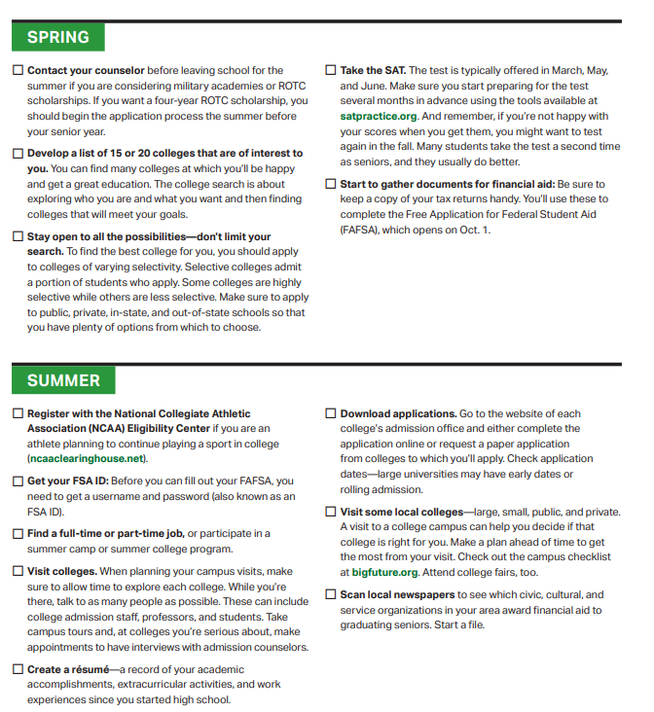

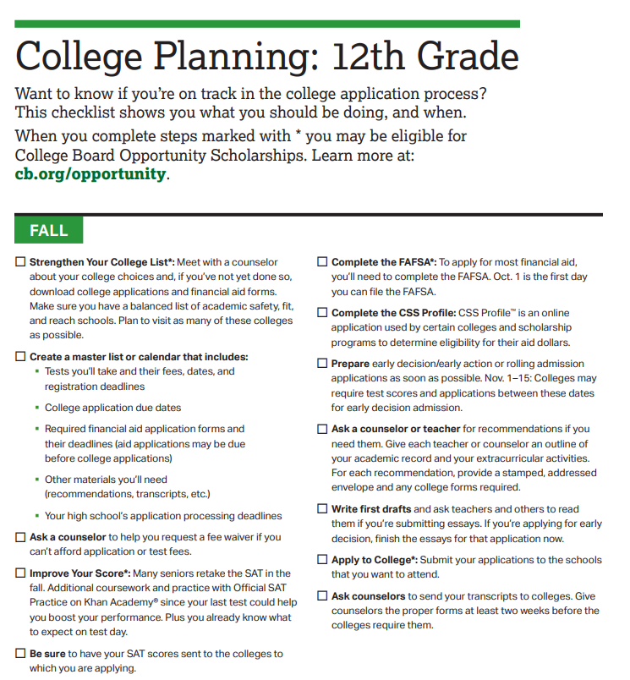

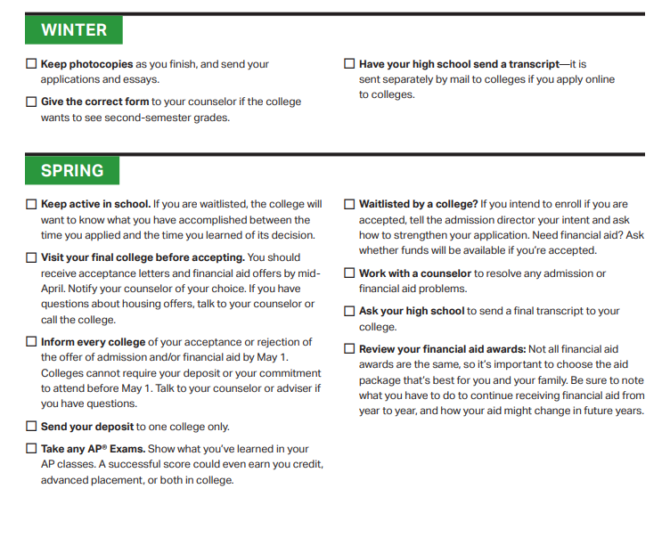

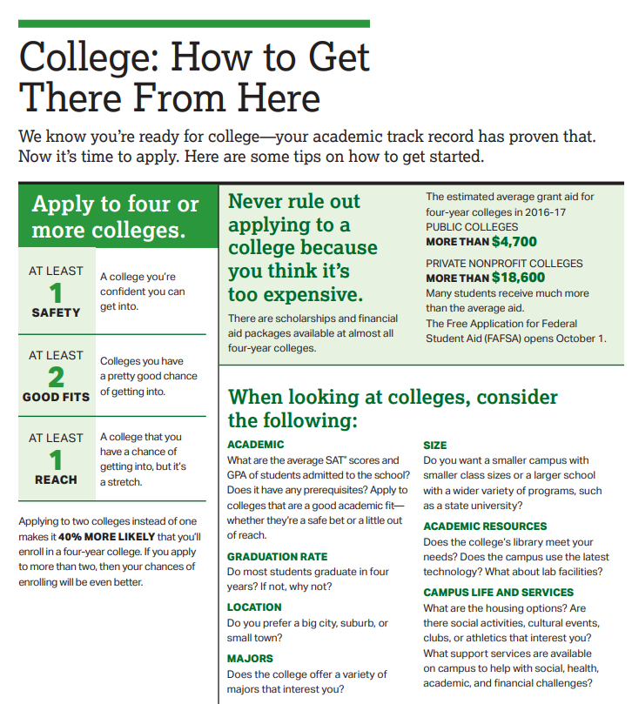

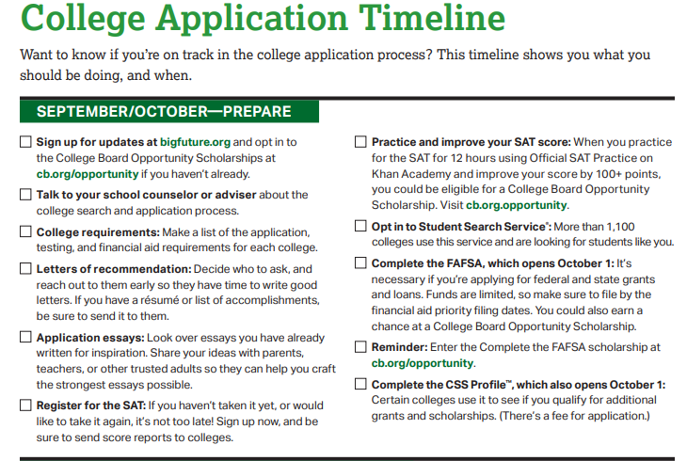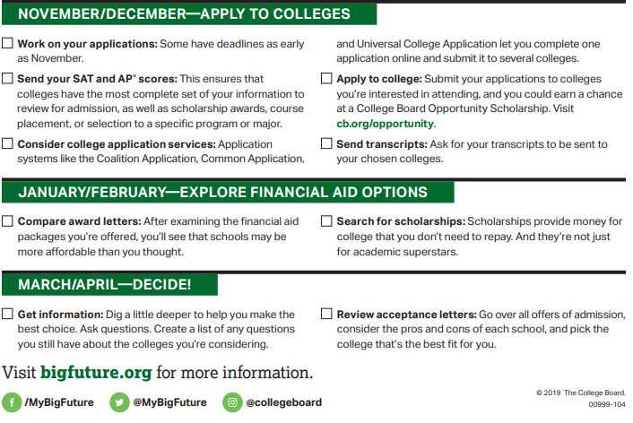

[Apply for Federal Student Aid (FAFSA)](https://studentaid.gov/h/apply-for-aid/fafsa)

[Applying for Financial Aid With the FAFSA® Form](https://youtu.be/UupEQdS2VMY)

## **Starting Your FAFSA® Form**

The 2024–25 FAFSA form is available now. We encourage you to fill out the form as soon as possible on or after the FAFSA launches to meet [FAFSA federal, state, and school deadlines](https://studentaid.gov/apply-for-aid/fafsa/fafsa-deadlines).

FAFSA® Filing Options

You may choose any of these methods to file a FAFSA form:

* Log in at [fafsa.gov](https://studentaid.gov/h/apply-for-aid/fafsa) to apply online
* Complete a [FAFSA PDF](https://studentaid.gov/resources#fafsa) (note: you must print out and mail the FAFSA PDF for processing)



