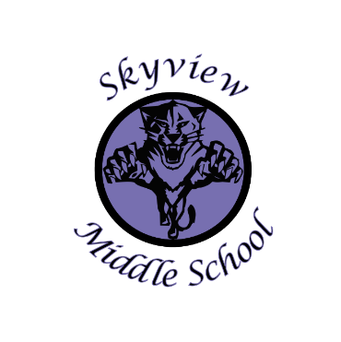
Skyview Middle School
Committee Name: Site Based Council
Date: May 4, 2022
Room B109

Meeting Facilitated by: Anna Simmons Type of Meeting: Site Based Council
Note Taker: Jill DuFloth
Attendees: Anna Simmons, 8th grade Parent Rep
Michelle Graves, Certified Rep
Jill DuFloth, Skyview Interim Principal
Kimberly Burton, Certified Rep
Alexis Simmons, 8th grade Student Rep
Shonia Werner, Skyview Assistant Principal
Amy Sommers, Skyview Teacher – guest

Call To Order: 3:34 p.m.

Approval of Agenda: Motion to approve agenda by Kimberly Burton, second by Michelle Graves, all in favor, none opposed, agenda approved

Approval Of Minutes: Motion to approve the January 20, 2022 SBC Minutes by Kimberly Burton, Second by Michelle Graves, all in favor, none opposed, minutes approved

Old Business: None

New Business:

Sources of Strength Year in Review:
Anna Simmons read a report provided by Shanna Johnson, Sources of Strength lead advisor about everything that Sources of Strength has accomplished this school year:
- September: peer leaders nominated by other students, and questions posed to students, “Who do you go to when you need a friend?.”
- October: National trainer, Dan, spoke to students about how to be positive and work on the strengths we already possess. Peer leaders built lessons to teach other students.
- November: built paper chains regarding positive friends and mentors, “Wanted Poster” contest, taught lessons on the strength of “generosity,” and completed Thankfulness journals.
- December: Created videos on healthy activities, and continued the generosity theme.
- January: implemented Healthy Activities and Mental Health logs to earn t-shirts and basketballs. Received a donation from Robert Winter and Hilcorp in the amount of $27,000 to Skyview Sources of Strength.
- February/March: Mental health and medical access themes. Students began to plan how to utilize donation monies including purchasing a VersiCam to make the program sustainable-with ability to create hats, t-shirts, etc. with inspiring sayings to sell. A student calming area with furniture, plants, and a TV with inspirational and informational content was purchased and set up for students to use and benefit from.
It has been an amazing, productive, and beneficial year for Skyview Sources of Strength and we look forward to continuing the momentum for next year.

New Staff – Skyview has had a number of staff changes and resignations for the upcoming school year, and due to that, there are a number of staff positions that have been hired or are in the process of being hired:
- Assistant Principal—John Galahan
- Music—Dianne Galahan
- Math—Steve Harrison
- Social Studies—Jacob Marshall
- Math—open
- .5 Social Studies--open
Review of Funds-- 710/100 account balance.
2021-22 Site Council Goals—Ms. DuFloth
- Goals Update: MAP testing has been completed and progress toward goal was calculated. Hanover results are not yet available, so goal results cannot yet be reported. An email will be sent to members once these results are and the final school improvement report is written.

Potential Changes to Skyview Handbook and Policies:
- Staff had requested that cell phones usage be limited. A survey was sent to teachers and 100% of teachers asked that cell phone usage be limited to before school, during lunch, and after school. This is in-line with board policy as well.
BP 5128

Elementary and middle school students (grades K-8) may use such devices only before and after school. Additionally, no student may use a cellular phone or personal electronic device in a manner, or at a time, that interferes with or is disruptive of other students’ instructional time.

- Teachers were also requesting that students’ consumption of energy drinks be prohibited. Mrs. Werner said that currently teachers have the ability to not allow them in their classrooms. She is going to check on whether board policy has any language to support a ban or limit on energy drinks or not.
- Dress code presentation: Teacher Amy Hoffman presented a proposal for the site council to change the current dress code. Proposed changes were created by a teacher-committee last school year, and read by Ms.Hoffman. She also read research gathered by the committee, as well as a letter submitted by a Skyview student. Questions and a discussion was had about the dress code. Ms. Hoffman said that she realized that no changes would be made at this point, but that she and others that support changing the dress code wanted a reading of the proposed changes and reasons behind those proposed changes so that it can be formally proposed to the site council in the new school year. Mrs. Werner stated that while there would not be action on it this year, there would be opportunity for teachers, parents, and the site council to consider potential changes to the dress code at the start of the school year 2022-2023. Ms. Hoffman thanked the site council for listening.

Meeting adjourned 4:16 pm Motion for meeting to be adjourned was made by Michelle Graves, and seconded by Alexis Simmons.

