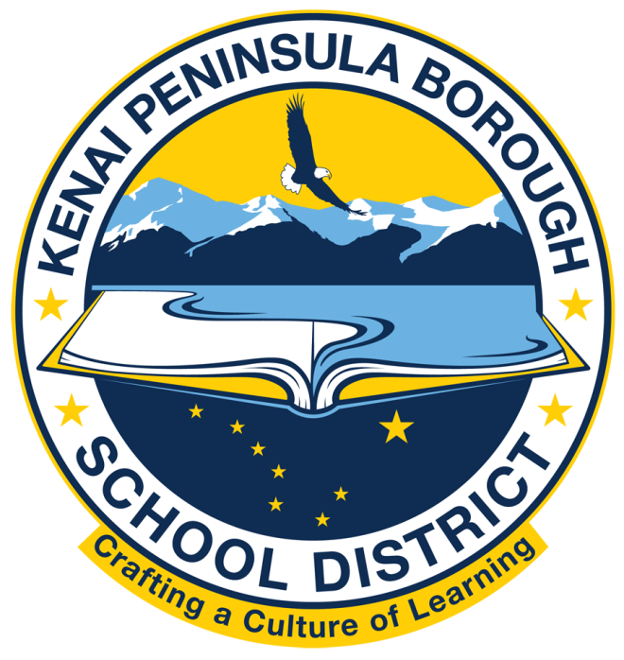

Kenai Peninsula Borough School District

Office of Superintendent
Clayton Holland, Superintendent
148 North Binkley Street Soldotna, Alaska 99669-7520
Phone (907) 714-8888

June 5, 2024

Dear Parents/Guardians,

The System for School Success is Alaska’s accountability system designed to celebrate success in our schools and identify areas we can focus on to help provide additional support. This accountability system fulfills the requirements under Every Student Succeeds Act (ESSA) to regularly evaluate school efficacy and close gaps in student achievement.

Accountability systems are not meant to be punitive. State standards and assessments are set as expectations for what students should know and be able to do. Accountability systems help to set the expectations for school performance and effectiveness and are one of the ways we can identify what is working well and what we need to improve. A brief overview of Alaska’s accountability system can be found at: education.alaska.gov/akaccountability/schoolsuccess/accountabilitysystems.pdf.

Alaska’s accountability system allows us to:

- Articulate goals for student achievement, growth, and success
- Collect, analyze, and report on school performance
- Recognize high-performing schools and provide additional support to schools when needed

There are five designations that schools can receive under Alaska’s accountability system:

- Additional Targeted Support and Improvement (ATSI
- Comprehensive Support and Improvement 5% (CSI 5%)
- Comprehensive Support and Improvement-Grad Rate (CSI-Grad rate)
- Comprehensive Support and Improvement-Targeted Support and Improvement (CSI-TSI)
- Universal Support

School report cards can be found on the Alaska Department of Education and Early Development’s website (https://education.alaska.gov/akaccountability) under System for School Success.

Sincerely,
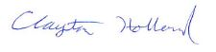
Clayton Holland
Superintendent

