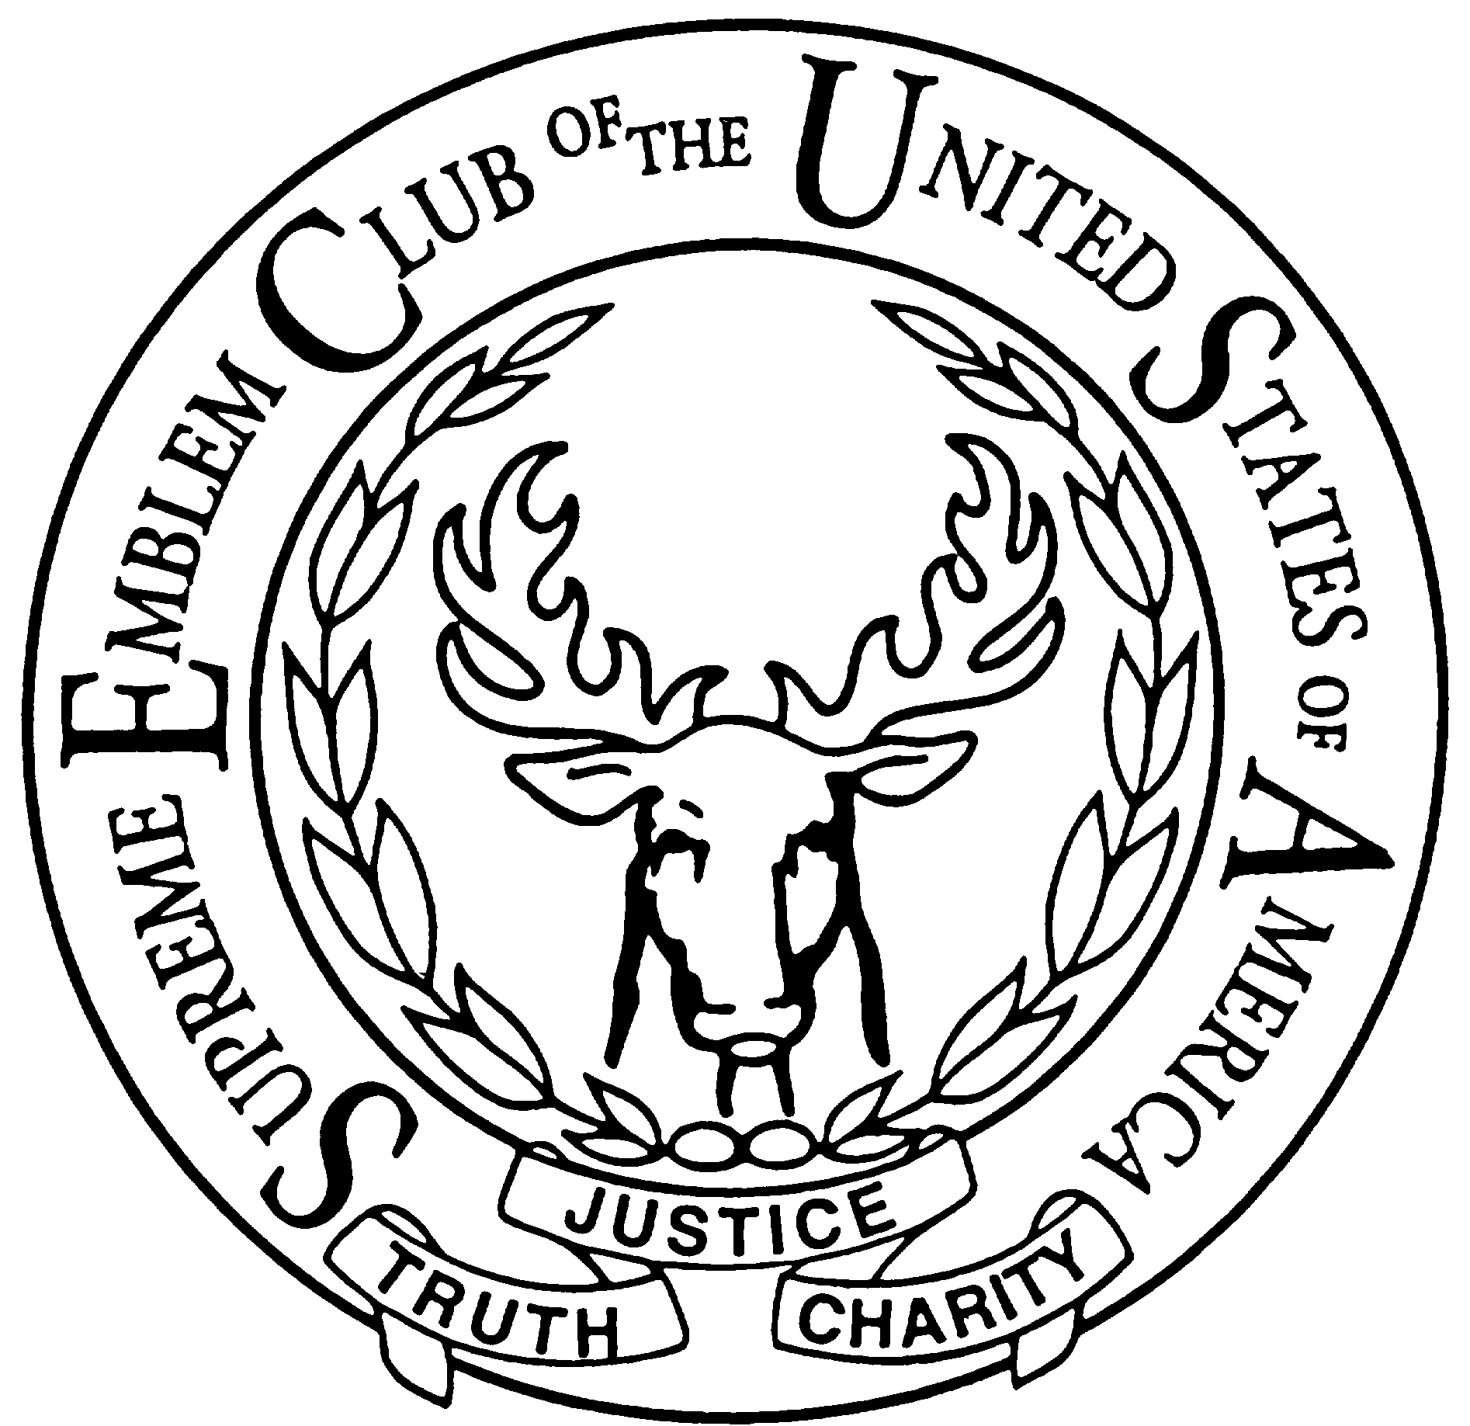
Homer Emblem Club #350
2023 Scholarship Application

January 2023

Here is the 2023 Emblem Club #350 Scholarship Application. You should receive a total of six pages including this cover letter. The Scholarship award is $500 to $1,000. If you have any questions concerning the application or how to fill it out, please let me know. You do not need to be affiliated with an Elk or Emblem member to be considered for this scholarship.

To be eligible you must be a student on the lower Kenai Peninsula (Ninilchik, Homer, Anchor Point, Seldovia, Nikolaevsk, Nanwalek, or Port Graham). Applications will be scored based on the following criteria: scholastic performance, financial need, leadership abilities, community involvement, educational goals, achievements and activities, completeness, neatness, and timeliness.

Please note that payments can only be made to the college, university, or vocational/technical school that you will be attending. We cannot give you the funds directly.

This is your original. Please make as many copies of the applications as you need. I need completed applications returned by April 8, 2023. Completed applications can mailed to Homer Emblem Club, PO Box 614, Homer, AK 99603 or dropped off at the Homer Elks Lodge, 219 Jenny Lane, Homer. Please mark envelope: Attention: Nancy Bishop, Scholarship Application Enclosed.

Sincerely,

Nancy Bishop
Scholarship Chairman
Homer Emblem Club #350
907-299-7612
Annish3@yahoo.com

